Orkney Pilgrimage

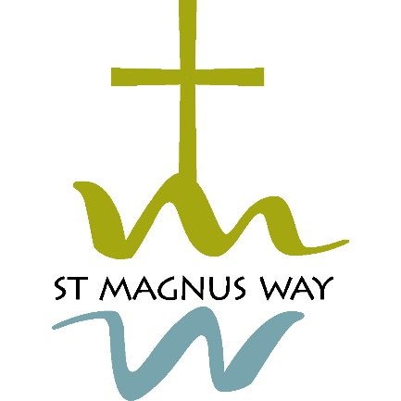
Scottish Charity Number: SC047008

Annual Report
For the year ended 31st December 2024

Charity contact information
Orkney Pilgrimage
c/o Amaroo
Harray
Orkney
KW17 2JT
Email info@stmagnusway.com
Website www.stmagnusway.com
Facebook www.facebook.com/stmagnusway

Charity Trustees at 31st December 2024
Caroline Butterfield
Brenda Dowie, Secretary
Sheila Garson, Chairperson, appointed 20/03/24
Sarah Jane Gibbon
Alison Hawkins, Treasurer
Fran Hollinrake, appointed 16/01/24
Pirjo Little, resigned 30/09/24
Stuart Little
David Mazza

Objectives and activities
Orkney Pilgrimage was established in September 2016 to facilitate the development of the St Magnus Way, a 55 mile pilgrimage route through Orkney.
Orkney Pilgrimage’s purposes are:
1 The advancement of spiritual wellbeing in Orkney through the development of local pilgrimage routes and resources. In particular, to establish and promote the St Magnus Way pilgrimage route in Orkney.
2 The advancement of education in local heritage and environment by the development of educational resources associated with pilgrimage.

Achievements and performance
Orkney Pilgrimage is going through a period of consolidation as it works to secure a sustainable future for the St Magnus Way.
During 2024 we undertook an organisational review and a board training session both of which were useful in ensuring we are fulfilling our charitable purpose and conduction our business appropriately.
As always, we are hugely indebted to our dedicated volunteers who monitor and maintain the route, lead guided walk, look after our website and social media sites and a plethora of other essential tasks which make up the core of our work. Without them there would be no St Magnus Way.
Work continues on the Virtual St Magnus Way project which will make the Way accessible to anyone, anywhere and we very much hope to be able to launch this in the very near future. We are indebted to the drive and enthusiasm of the volunteers who have worked tirelessly to deliver this project.
The work to develop a pilgrim passport has made good progress during the year and again we are indebted to the volunteers who have taken this forward.
During the year we applied to all the Community Councils along the route for financial assistance and all made a donation. In common with many charities, securing funding to cover our running costs is an ongoing issue.
Stuart Little stood down as Chair during 2024 and Pirjo Little from her role as Volunteer Coordinator and we thank them both for all their work over the years.

Structure, governance and management
Type of governing document
As a single tier Scottish Charitable Incorporated Organisation we are governed by a written constitution.
Trustee recruitment and appointment
Our trustees have a diverse range of experience and are recruited to meet the needs of the charity from interested Orkney residents. One third (being the longest in office since last appointment or re appointment) together with those appointed since the previous annual general meeting retire at each annual general meeting but are eligible for re-appointment and are deemed to be re-elected at the next board meeting unless they advise the board that they do not want to be re-elected or a resolution for that person’s re-appointment is put to the board and is not carried

Financial review
In our eighth year of operation, we managed to secure a total of £1,850 in grants, of which £1,650 was support from Community Councils, and a £200 for Covid Recovery Grant. A further £1,310 in unrestricted donations and merchandise sales brought our total income for the year to £3,160. During the year we spent a total of £4,135, of which £3,600 related to development of the Virtual St Magnus Way, and the majority of the balance was for path development and maintenance, website services and insurance costs. Our accounts for the year are appended to this report and provide further detail on our income and expenditure.
Statement of the charity’s policy on reserves
It is the trustees' policy that, within five years of being established, we should maintain sufficient reserves to cover the next six months' operating costs. At 31 December 2024, the total reserves of £5,320 were sufficient to cover the next six months' planned expenditure.

